**The Reflex Arc Comprehension Activity**

**Instructions:** Read the following passage about the concept of a reflex arc in biology. Then answer the questions on the information.

A reflex arc is a neural pathway that mediates a reflex action, allowing for rapid, involuntary responses to stimuli without involving conscious thought. This efficient and automatic process involves sensory neurons, interneurons, and motor neurons, forming a coordinated circuit to swiftly transmit and process information.

1. **Sensory Receptor:** The reflex arc begins with a sensory receptor, which detects a stimulus such as heat, pain, or pressure. Sensory neurons, also known as afferent neurons, carry this sensory information towards the central nervous system.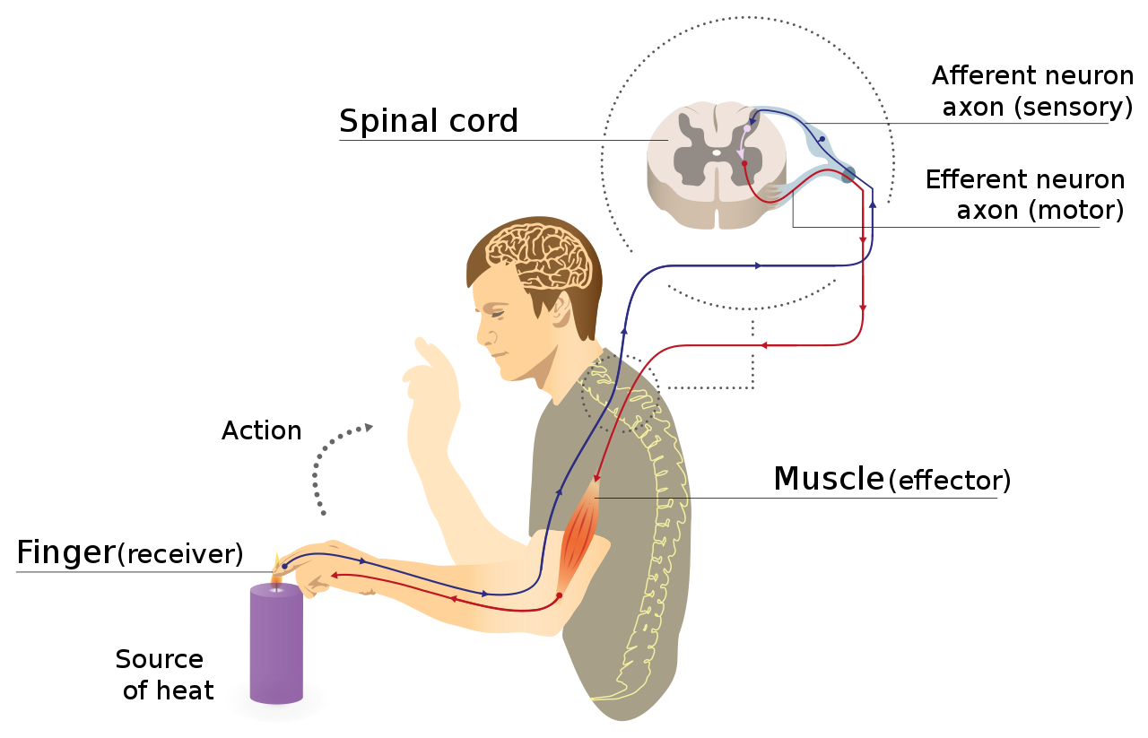

2. **Spinal Cord Processing:** The sensory neurons synapse with interneurons within the spinal cord, forming the central integration center of the reflex arc. Interneurons process the incoming sensory information, facilitating a rapid response without the need for input from the brain.

3. **Motor Neuron Activation:** Interneurons activate motor neurons, also known as efferent neurons, which carry signals away from the central nervous system. These motor neurons transmit signals to effectors, typically muscles or glands, initiating a response to the original stimulus.

4. **Effector Response:** The effector, usually a muscle or gland, carries out the response dictated by the reflex arc. In the case of a muscle, this response could be a contraction or relaxation, while a gland might release a specific substance.

5. **Effector Response and Adaptation:** The rapidity of the reflex arc allows for swift and instinctive reactions to potentially harmful stimuli. Additionally, the involvement of interneurons enables a degree of adaptation, adjusting the response based on the specific circumstances.

The classic example of a reflex arc is the patellar reflex, commonly known as the knee-jerk reflex. When the patellar tendon is tapped, sensory neurons detect the stretch, initiating a reflex arc. Interneurons in the spinal cord quickly transmit signals to motor neurons, leading to the contraction of the quadriceps muscle and the extension of the leg.

Reflex arcs are crucial for survival, providing swift responses to potentially dangerous situations. While the spinal cord is involved in many reflex arcs, some reflexes, such as those involving complex decision-making, may also include the brain in their neural pathways.

In conclusion, reflex arcs are essential neural pathways that enable rapid and automatic responses to stimuli, showcasing the efficiency and adaptability of the nervous system in protecting and maintaining the body.

---

**Questions:**

1. What is a reflex arc, and what is its primary function?

2. Describe the components of a reflex arc, including sensory neurons, interneurons, and motor neurons.

3. Where does the reflex arc typically begin, and what role do sensory receptors play?

4. Explain the processing of sensory information within the spinal cord during a reflex arc.

5. How do interneurons contribute to the rapid response of a reflex arc?

6. What is the role of motor neurons in a reflex arc, and what are effectors?

7. Provide an example of a reflex arc and describe the sequence of events in that reflex.

8. How does the rapidity of a reflex arc contribute to the body's ability to respond to stimuli?

9. In what situations might the involvement of interneurons in a reflex arc allow for adaptation in the response?

10. Why are reflex arcs considered essential for survival, and how do they showcase the efficiency of the nervous system?